Holy Eucharist Rite II: The Ministry of the Word

Prelude Music
Processional Hymn #390……. “Praise to the Lord, The Almighty”
The service is followed in the Book of Common Prayer
Opening Sentence………………………………………p. 355
Gloria in Excelsis: “Glory to God”………………….… S280
Opening Collect………………………….……. bulletin insert
The children proceed to the Hall at this time for Sunday School, and will return at the passing of the Peace.

Old Testament Reading…………………..……. bulletin insert
Psalm…………………………………………..bulletin insert
New Testament Reading……………….… …… bulletin insert

Celtic Alleluia (Sung before and after the Gospel is read)
Gospel ……….. (All stand)…..…………….…. bulletin insert

Sermon:……………………....………........Fr. Ray Ryerson

Nicene Creed…………………………………… .. …p. 358

Prayers of the People…………………. ….. p. 387(Form III)
Special prayer For the Election of our new Bishop:
Almighty God, giver of every good gift: Look graciously on
your Church, and so guide the minds of those who shall
choose a bishop for this Diocese, that we may receive a faithful pastor, who will guard the faith, and who will care for your
people and equip us for our ministries; through Jesus Christ
our Lord. Amen.

Those in need of our prayers: For healing: Bernie, Dan, Adeline, Bruce, Pam, Connie, Frances; Aaron, Ken, and all those deployed.
Diocesan Cycle of Prayer: St. Peter’s, Ripon

Confession …………….….....................................p. 360
Priest pronounces absolution of sins

The Peace - please greet each other in the name of Christ

Offertory Hymn #676..“There is a balm in Gilead”

"Praise God from whom all blessings flow"...Hymnal #380 v 3

The Great Thanksgiving
Eucharistic Prayer…Form A………………………….p. 361
Sanctus -“Holy, Holy, Holy”……. …………Hymnal # S130
All baptized Christians are welcome to receive Holy Communion
Post Communion Hymn …#605. “What Does the Lord Require”
Concluding Prayer: ……………..…..………………..p. 366

Blessing

Recessional Hymn . . Hymnal #594…..“God of Grace and God of Glory”

Dismissal, Announcements and Postlude
+++++++++++++++++++++++++++++++++++++++++++
Please come to the Hall for refreshments and fellowship, and to welcome Father Ray Ryerson as our preacher and celebrant this morning.

Welcome, visitors! Please see the pews for a special welcome card and information on St. John's.

This Week at St. John's:

Wed, Sept 25: 11 AM or 6:30 PM, The Wednesday Discussion Group, in Hall on Luke - after 11 AM group
Noonday prayer.

St. John's Upcoming Events:
Oct. 20: Potluck celebration after mass
Nov. 3: 11 AM Bishop's Committee Meeting
Nov. 27, 7 PM, Shawano Ecumenical Thanksgiving Service, Sacred Heart Parish

Announcements

Our Sunday School is open to all children, even those who do not come to church with their parents? Sunday School is such an important thing in raising up the new generation.

Please keep in your daily prayer our Diocesan Bishop search process. Stay up to date on the process. Look at the Diocesan website for the latest information.
http://www.episcopalfonddulac.org/bishopsearch/index.htm

Please bring non-perishable (canned or dried goods) foods to church and place them in the basket near the Church entrance; food is delivered weekly to the Shawano Food Pantry (check dates on food please). You can also bring cleaning supplies and toiletry items for those staying at the Shawano Domestic Abuse Shelter; please place these items in marked bins.

See Pastor Mary's new blog: www.marytrainor.blogspot.com

PICK UP IN THE RACK IN THE HALL:
- flyers that tell you about St. John's
- printed copy of the Church and Diocese electronic newsletter
- tracts that help with life's issues

Diocesan Calendar
10/3: Bishop candidates - meet them at St. John's, Wausau
10/4: Bishop candidates - meet them in Fond du Lac
10/18-19: Diocesan Convention, Fond du Lac (elect new bishop)
4/26/14: Consecration of the new Bishop of Fond du Lac

St John’s staff:
Vicar- The Rev. Mary S. Trainor; Organist – Ted Myers
Bishop’s Committee: Senior Warden - Ron Stezenski; Jr. Warden- Art Frieberg; Marlene Brown, Nancy Clasen, Joe Keberlein, Wendy Hafner, LouAnne Zander; Treasurer - Sue Sazama; Clerk – Lois Renner; Youth Liaison, Ted Myers.

The Eighteenth Sunday after Pentecost
September 22, 2013

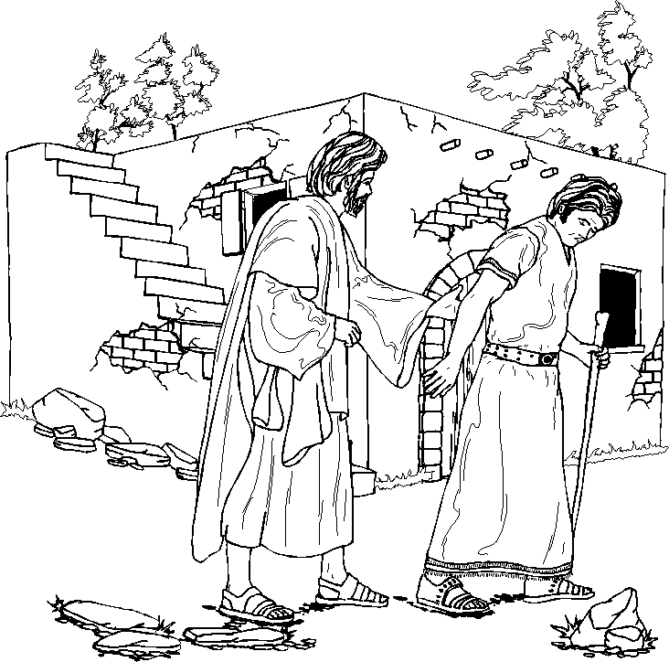
“What is this I hear about you?”

St. John’s Episcopal Church

141 South Smalley St., Shawano, WI

http://www.shawanoepiscopal.org

The Rt. Rev. Russell Jacobus, Bishop

The Rev. Mary S. Trainor, Vicar

Church Phone 715-526-3686

Vicar’s Phone 715-252-4816

pastormaryt@gmail.com
www.marytrainorblogspot.com

